Name: World History B - TB

Date:

Name and date are required! You will lose points if you leave them off!
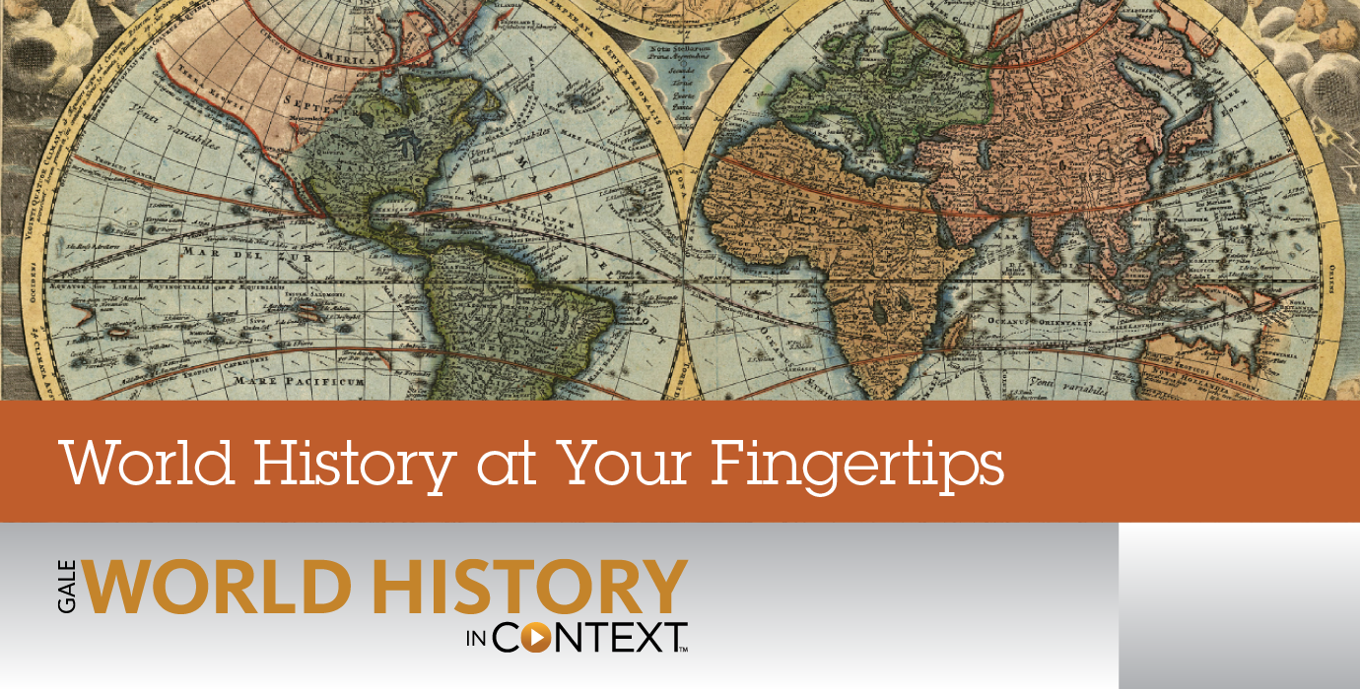
Unit 8 Section 2
Course overview: World History is a survey course covering from early civilizations to modern times, with emphasis on the political and philosophical roots of western democracy. Topics include: the rise of democratic governments; political, social and economic developments of the Middle Ages; the Renaissance and era of discovery; the growth of democracy and nationalism; the industrial revolution; and the two world wars. Postwar problems and recent developments are also studied.
CA State Standards:

10.6 Students analyze the effects of the First World War.
1.Analyze the aims and negotiating roles of world leaders, the terms and influence of the Treaty of Versailles and Woodrow Wilson’s Fourteen Points, and the causes and effects of the United States’ rejection of the League of Nations on world politics.
2.Describe the effects of the war and resulting peace treaties on population movement, the international economy, and shifts in the geographic and political borders of Europe and the Middle East.
3.Understand the widespread disillusionment with prewar institutions, authorities, and values that resulted in a void that was later filled by totalitarians.
4.Discuss the influence of World War I on literature, art, and intellectual life in the West (e.g., Pablo Picasso, the “lost generation” of Gertrude Stein, Ernest Hemingway).

Assignments:

Worksheet: Archduke Francis Ferdinand
Chapter 27 Lesson 1: World War I Begins
Worksheet: The Assassination of Archduke Francis Ferdinand
Worksheet: The Schlieffen Plan
Chapter 27 Lesson 2: World War I
Worksheet: Science and Technology of WWI
Worksheet: World War I in France
Worksheet: German Submarine Warfare
Chapter 27 Lesson 3: The Russian Revolution
Worksheet: WWI Russian Economy
Worksheet: Vladimir Lenin
Chapter 27 Lesson 4: World War I Ends
Worksheet: The Second Battle of the Marne
Check-in 8.2

Packet Directions
- These packets are assessed coursework.
- You will be scored based upon completion, effort, and accuracy.
- All short answer questions are to be completed IN YOUR OWN WORDS! Answers copied from online sources will not receive credit
Unless a question specifically asks you to cite or quote from the text, answers copied word for word or cut and pasted from the online text (even with quotations) will be treated as copied and marked down. (See Inspire’s plagiarism policy in your course syllabus)
- When typing your responses please keep your answers in red font (when red font is provided)
- Packets are required to be uploaded as one whole unit and as one file (see the syllabus for details)
- Name and date are required! You will lose points if you leave them off!

-Content Vocabulary-
Directions: Use the textbook’s glossary to complete vocabulary words as you complete the unit. Looking them up online often gets you the wrong definition!
Conscription | Refers to enlistment of people into the military service by force
Propaganda | The use of biased information to propagate political cause
Trench warfare | Trench warfare is a type of land warfare using occupied fighting lines largely comprising military trenches,
War of attrition | A long-term period of conflict in which each side is seeking to wear down the other side using a series of actions
Total war | A war with no restrictions on the types of weapons being used
Planned economy | an economy in which production, investment, prices, and incomes are determined centrally by the government.
Soviet | councils composed of representatives from the workers & soldiers
Armistice | An agreement between two fighting sides to stop the war
Mandate | Permission given to somebody to do something
Reparations | A political justice states that requires Africans to be compensated for being oppressed and being taken for slavery

-Don’t forget to complete Key Assignment #8 by 4/21-

-Worksheet: Archduke Francis Ferdinand-
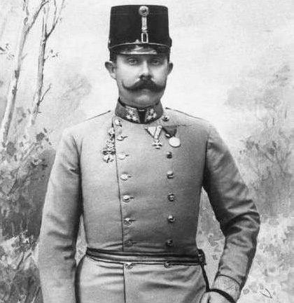
Archduke Francis Ferdinand (1863–1914)
Archduke Francis Ferdinand was the nephew of Francis Joseph, the emperor of Austria-Hungary from 1848 to 1916. When both Francis Joseph’s son and Ferdinand’s father died, Francis Ferdinand became the next in line for the throne.
Ferdinand fell in love with Sophie, Countess von Chotek. She was of a lower social rank. He was allowed to marry Sophie only if he would forgo their future children’s rights to the throne. He did so, and they married in 1900.
Ferdinand understood that nationalism would not unite the multinational Austro-Hungarian population. Political focus needed to be placed on the crown, not nationality.
As inspector general of the army, Ferdinand visited Sarajevo with his wife in 1914. There they were assassinated by a Serbian, named Gavrilo Princip, who was seeking independence for his people from the Austrian-Hungarian Empire.

Please use the information above to answer the questions below – answers taken from other sources will not receive credit
1. Why was Archduke Ferdinand important to the Austrian-Hungarian Empire?
Answer: _____He kept the Austrian—Hungarian people captives_____

2. What sacrifice did he make for love?
Answer: _________he foregored his right to be king _

3. Using the textbook’s glossary: Define nationalism
Answer: ______ability of one to identify with his country and support for its interest_

4. Why did Ferdinand oppose nationalism at a time when most of Europe embraced it?
Answer: _________because nationalism made European nations more powerful_

5. Making Inferences/opinion: Why would a Serb nationalist want to assassinate Ferdinand?
Answer: __________Ferdinand was incharge of the annexation of Bosnia which Serbians believed should be their territory

-Chapter 27 Lesson 1: World War I Begins-
Directions: Read each main idea and answer the questions below. Refer to your textbook to write the answers.

A. Main Idea: Nationalism, alliances, imperialism, and militarism, contributed to the start of World War I. (Easily remembered with the acronym M.A.I.N.)

1. How did European imperialism contribute to the start of World War I?

Answer: ______they attacked the African and other areas of Europe leading to conflict that resulted to WW1____

2. How did nationalism contribute to the start of World War I?

Answer: ________they assassinated Ferdinand Franz so that they could drive Austria-Hungary from Balkans. This event led to the break of WW1__

3. What did the Irish, the Poles, and Slavic minorities in the Balkans and Austria-Hungary have in common?

Answer: ______ they were ethic groups that didn’t have stress of their own(so they joined other nations)____

4. How did industrialization contribute to militarism in Europe?

Answer: ____ industrialization offered new methods of shipbuilding and other military equipment.
5. What is militarism and how did it contribute to the start of WWI? (Include conscription in your response)

Answer: ______militarism is the organization of society for military conflict. Millitarism led to the Naval rivalry in 1900 that led to WW1

6. What nations formed the Triple Alliance and the Triple Entente?

Answer: germany, austria-hungary, and italy form the triple alliance. france, great britian, and russia form the triple entente

7. Sometimes governments will attempt to undermine challenges to their own authority by distracting the public
with the threat of a foreign enemy. How does this apply to the start of WWI?

Answer: __________ Most countries used propaganda to make their citizens angry that they are being attacked by foreigners so that they can fight back

B. Main Idea: The European response to a crisis in the Balkans led directly to World War I.

1. Who was assassinated during a visit to Sarajevo in Bosnia?

Answer: Archduke Francis Ferdinand
2. Why did Austria-Hungary seek German support before invading Bosnia?

Answer: It suspected that Russia would come to Bosnia’s defeat

3. Who ordered mobilization of troops, knowing that it would be considered an act of war?

Answer: Czar Nicholas II of Russia

4. Where did the Schlieffen Plan call for German troops to fight?

Answer: called for two front war against Russia and France and called for invading France by way of belguim

5. What nation started World War I, and what two nations escalated the conflict? Cite specific evidence for your response – in other words explain why.

Answer: Austria-Hungary but Germany and England escalated it.

Summary & Reflection

Directions: Using ideas from throughout the entire lesson, summarize the main ideas by answering the question below. Answers must be IN YOUR OWN WORDS. DO NOT RESEARCH ANSWERS ONLINE! Points awarded based on accuracy and effort.

1. a) List and briefly explain the four MAIN factors that started WWI?
b) Rank the four of them in order of importance to starting the war
(In other words, which one of the four do you think was the most influential cause of the Great War)
Justify your top selection with evidence from the chapter.
c) Explain how the assassination of archduke Ferdinand was only a “trigger event” and not the cause of the
Great War

Answer a): militarism because various nations wanted to showcase their military power and alliances that nations formed provoking their enemies. Also, imperialism and nationalism.

Answer b): militarism-alliances- imperialism- nationalism.

Answer c): Because the assassination of Ferdinand only led to the war between Austrians and the Serbian and not the whole world.

-Worksheet: The Assassination of Archduke Francis Ferdinand
The “trigger event” of WWI-

Background
The attack that killed Archduke Francis Ferdinand in Sarajevo on June 28, 1914, was the second attempt on his life that day. Earlier, a would-be assassin had hurled a grenade at the archduke’s car but missed. Ferdinand, upon arriving at city hall a short time later, railed publicly at the mayor, “What is the good of your speeches? I come to Sarajevo on a visit and I get bombs thrown at me. It is outrageous!” Mere hours later, he was dead.

Given the fact that Austria-Hungary declared war on Serbia only a month later, it might seem that Ferdinand had been either a crucial enemy to the Serbs or a beloved figure in his own nation. The reality was that his murder at the hands of a Serbian nationalist was just the excuse Emperor Francis Joseph of Austria-Hungary felt he needed to exert his political will over Serbia, a place that had long been problematic and costly to Austria-Hungary. In 1908 Austria-Hungary had assumed control of Bosnia, a former Turkish province that the Serbs felt should be under their control. Serbia threatened to go to war with Austria-Hungary; Russia aligned itself with Serbia. By 1914, tensions between Serbia and Austria-Hungary remained high.

Rather than fighting only Serbia as it had intended, Austria-Hungary’s July 1914 declaration of war inflamed the web of international alliances that started to develop starting back in 1879. In that year, Germany had entered into the Dual Alliance (also known as the Austro-German Alliance) with Austria-Hungary in an attempt to protect itself from isolation. Germany believed Russia would be unwilling to wage war against the combined forces of Germany and a powerful ally. In 1882, Italy had joined with the Dual Alliance powers to create the Triple Alliance. Russia, aware of the growing military potential of this triumvirate of powers, entered into the Triple Entente, a military alliance with France and Britain in 1907. Given the situation, it took only a relatively small event—the murder of Archduke Ferdinand—to launch a world war. Russia quickly moved to defend its ally Serbia. Austria-Hungary’s ally Germany saw itself at risk from both Russia and France, and it too prepared for war. It was only a matter of time before the Triple Alliance powers squared off in deadly warfare with the Triple Entente.

Directions: The following excerpts are from an article printed in the British newspaper Manchester Guardian on June 29, 1914, one day after the assassination of Francis Ferdinand. Read the selections. Then answer the questions.

The Archduke Francis Ferdinand of Austria, nephew of the aged Emperor and heir to the throne, was assassinated in the streets of Sara[j]evo, the Bosnian capital, yesterday afternoon. His wife, the Duchess of Hohenberg, was killed by the same assassin. Some reports say the Duchess was deliberately shielding her husband from the second shot when she was killed.

One victim was struck in the body and the other in the face; the telegrams are contradictory about which wound the Archduke suffered and which his wife. . . .

Bosnia and Herzegovina have been in Austrian occupation since 1878, when the Treaty of Berlin authorised the dual monarchy to hold the two provinces. In 1908 Austria, without consulting the other parties to the treaty, annexed the occupied territory. Austria-Hungary is, as a result of territorial divisions and constitutional differences, ruled partly by the Germans and partly by the Magyars. The Slavs, who are a great majority of the people, numbering 22,500,000 against 11,000,000 Germans and 9,000,000 Magyars, remain indignantly hostile to such a political system.

—Manchester Guardian, June 29, 191

Questions for Worksheet: The Assassination of Archduke Francis Ferdinand
The “trigger event” of WWI-

Please use the information in the article above to answer the questions below – answers taken from other sources will not receive credit

Background questions
1. If Archduke Ferdinand was more cautious, why should the attack that ultimately killed him not have happened?
Answer: after a first assassination attempt on his life failed, Ferdinand went ahead to mock the mayor for trying to kill him. This might have provoked the mayor.

2. How did Austrian-Hungarian emperor Francis Joseph use his nephew’s assassination?
Answer: he used it to start a war between Austrian-Hungarian people and Serbia with its allies

3. Long before Austria-Hungary declared war on Serbia over the assassination, setting off WWI, what tensions
existed between the two?

Answer: Austrian-Hungary had annexed larger parts of Bosnia which Serbia believed it should be their territory

4. What was the date of the origins of the alliance system that eventually went to war in 1914?

Answer: 1979

Primary source questions

1. Why was it significant that the assassination of Francis Ferdinand occurred in Sarajevo?

Answer: because Ferdinand was believed to be the enemy of Serbian people

2. Describing: What were the effects of Austria’s annexation of Bosnia and Herzegovina?
Answer: it led to the war between Austria and Serbia

3. Analyzing: a) What do details in the first part of the excerpt tell about the nature of breaking news stories in the 1914 press as compared to today? b) How does the second part differ from the first in terms of its tone and information?

Answer a): in 1914, the reporting of news about the death of people was not done remorseful unlike its today.

Answer b): The modern-day reporting uses empathy and remorseful words such as “we regret to announce”

4. Detecting Bias: Do you think there is bias—intentional or not—in the excerpts? Explain your answer.
Answer: Yes, there bias because it mentions that Ferdinand is the nephew of the aged emperor which is not necessary for public consumption.

-Worksheet: The Schlieffen Plan-
Political geography, a subdivision of human geography, examines the connection and interactions between geography and politics. Geopolitics concerns the foreign policies of individual states that are determined by each state’s location, natural resources, and physical attributes. Geographers use both of these concepts to study international conflicts, such as World War I. The Schlieffen Plan was a military strategy that the Germans implemented at the outset of World War I.

As the conflict between Serbia and Austria-Hungary broadened to include other European nations, Germany, located in Central Europe, found itself facing rivals to its west (France) and its east (Russia). The Schlieffen Plan was named after Count Alfred von Schlieffen, former chief of the German general staff, who formulated it years before the outbreak of World War I. By the time he retired in 1905, Schlieffen had developed the plan that would be used when war broke out in 1914.

In creating his plan, Schlieffen considered the political geography of Europe. Instead of first concentrating on a strike against Russia before fighting France, Schlieffen suggested invading northern France with a large force by marching through Belgium, a neutral country, and then sweeping around to the south to crush the French armies with a smaller German force. Germany’s coastline was blocked from the Atlantic Ocean by the breakwater of the British Isles, so the invasion would have to be over land.
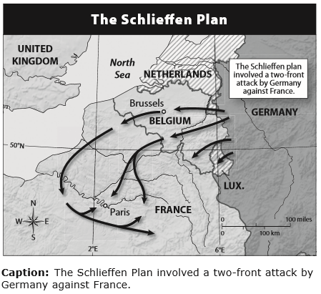
Why did Schlieffen think Germany could delay conflict with Russia and attack France first? Schlieffen considered Russia’s location, resources, and physical attributes. He knew that in the event of a war, Russia would need time to mobilize and assemble its forces, given the immense size of the country, its sparse rail system, and the inefficiency of its government. Because of this, Schlieffen suggested using a minimal number of defensive troops (just one-eighth of total troops available) to face Russia on the Eastern Front while concentrating most of its troops (the other seven eighths) on the Western Front against France. A quick victory in France would then free those German troops to concentrate on the Russian menace once Russian troops had mobilized in the east. The plan might have worked, but it was modified by Helmuth von Moltke, who used a smaller attacking army than Schlieffen had recommended and was later blamed for Germany’s failure to achieve a fast victory.

Please use the information above to answer the questions below – answers taken from other sources will not receive credit
1. How did the political geography and geopolitics of 1914 Europe influence the development and implementation of the Schlieffen Plan?

Answer: the central location of Germany in Europe meant that it had to defend itself against its enemies that surrounded it.

2. Explain why Germany’s location in Europe contributed to its being involved in a two-front war.

Answer: Germany is located in central Europe and when the war broke out, it found itself facing rivals from west (France) and Russia (east).

3. Drawing Conclusions: Notice that neutral Belgium is located between Germany and France. How do you think Belgium and the rest of the world regarded Germany’s violation of Belgium’s neutrality?

Answer: Belgium was negative about Germany’s move because it would disrupt peace that existed.

-Chapter 27 Lesson 2: World War I-
Directions: Read the lesson and complete the outline below. Refer to your textbook to fill in the blanks.

I. 1914–1915: Illusions and Stalemate
A. After the Germans were stopped at the First Battle of the ___Marine_______________ , both sides dug in, and _______trench lines__________ stretched from ____English Channel______________ to the border of ___Switzerland_______________ .

B. Unlike the ______Western____________ Front, the war on the _Eastern_________________ Front was marked by mobility.

C. Germany and Austria–Hungary defeated ______Russia____________ but lost ___Italy_______________ as an ally after the nation switched sides.

II. Trench and Air Warfare
A. German and French trenches alike were fortified with ______Barbed wire____________ and ___machines guns_______________ .

B. Between 1916 and 1917 _______millions___________ of men died; at the Battle of Verdun alone more than 700,000 died; the war had turned to into a deadly war of ____attention______________ .

C. By 1915, ____________airplanes______ started to be used in the war; they were originally used for reconnaissance; then they attacked enemy ________communication targets__________ .

III. A World War
A. The _____________Ottoman_____ Empire joined the___central_____________Powers; __________Arab________ princes were urged to revolt against their Ottoman overlords, organized by an undercover British officer know as ______Lawrence of Arabia_____________________.

B. _______Japan___________ took over several German colonies in the Pacific, and _____Australia_____________ seized New Guinea.

C. The sinking of the __________Lusitania________ and Germany’s continued use of______submarine___________ __________________ warfare brought the United States into the war in 1917.

IV. The Impact of Total War
A. As total war continued, governments ______drafted____________ millions of young men to fight; set up price, wage, rent, and industrial controls; and ______rationed____________ food.

B. As civilian morale sank, governments progressed from issuing propaganda to controlling ___dissent_______________ and ___________consering_______ news about the war.

C. Women’s wartime contributions brought them economic _________Independence_________ and won them ________sufface__________ in Germany, Austria, and the United States, after the war ended.

Summary and Reflection
Directions: Summarize the main ideas of this lesson by answering the question below.

WWI Diary - Write a fictional short story about yourself as a soldier during WWI. Your story must be historically accurate but the specifics of what you do can be as creative as you want them to be.
Include details and descriptions of the following items from Lesson 2 in your story:
1) propaganda, 2) the Western Front 3) trench warfare (see description p.544 under subheading “trench and air warfare”),
4) First Battle of the Marne, 6) Chemical warfare (see the worksheet that follows this packet) 6) war of attrition, 7) Battle of Verdun, and 8) entry of the United States

Answer: As one of the French generals, I was deployed with my team in the western front in August of 1914 to fight the Germans. On the western Front, I directed soldiers to be fighting in trenches to avoid being gunned by the enemy. On 6th September 1914, the British Army Joined us to fight the Germans in what was called the first battle of the Marne. We used chemicals such as tear gas to suppress the German soldiers. On 21 February 1916, I was still leading my soldiers in fighting against the Germans in what was now called the Battle of Verdun. The ferocity of this war and the many lives that were lost prompted the U.S to enter into this War supporting us in fighting Germans.

-Worksheet: Science and Technology of WWI-
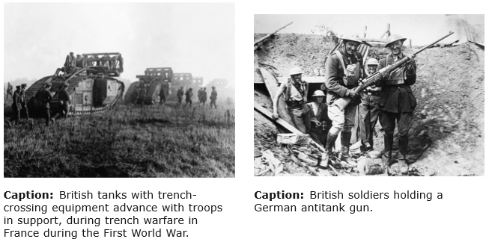
The new military technologies introduced during World War I, the first truly modern war, changed the very nature of how wars were fought and won. These technologies not only made World War I deadlier than previous wars but also caused psychological damage to soldiers.

Directions: The photographs present some of military technologies that made World War I more devastating than all previous wars. Look closely at the photographs, read the captions, analyze the images, and answer the questions that follow.

Background
World War I was marked by a staggeringly large loss of life. Almost 8.5 million soldiers had died by the end of the war. Millions were killed by weapons never before used in war, such as new kinds of guns and artillery as well as poison gas. World War I also marked the beginning of mechanized war—war fought with motorized vehicles—and aerial warfare.

The British developed the first tanks, which were a response to the challenges of traveling through the trenches. They moved on tracks instead of wheels and could roll through trenches and other impediments, such as barbed wire. Early tanks were slow and clumsy, but their armor repelled most small arms. Changes in how war was conducted prompted innovation: the creation of antitank weapons such as mines, missiles, and large-caliber rifles like the German 88-millimeter antitank gun, which could easily destroy tracks and penetrate tank armor.

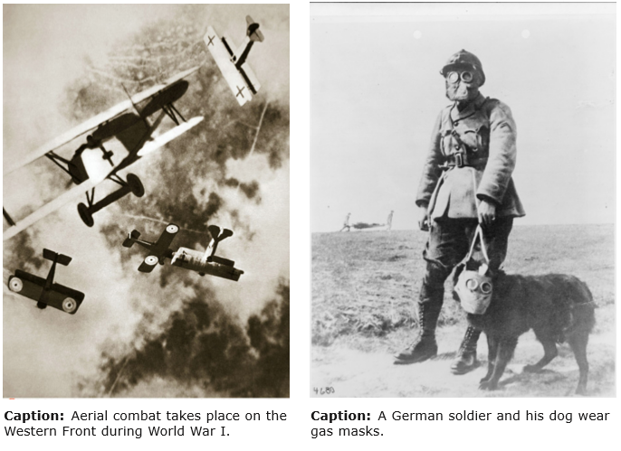
Aerial warfare first involved pilots shooting at enemy planes with small firearms like pistols, but the practice was very dangerous, as bullets could ricochet off the propeller and kill the pilot. In 1915, the Germans developed a machine gun that could be mounted on a plane; the machine gun was precisely timed to shoot its artillery safely between airplane propeller blades. Armed aerial engagement led to deadly, acrobatic dogfights in the sky as aviators sought to shoot down enemy planes. World War I pilots developed the art of the surprise attack and engaged in phenomenal feats of diving and climbing in the air. Only later in the war were airplanes used for ground attacks, dropping bombs on enemy targets and conducting strafing runs with their mounted machine guns.

Modern chemical warfare began in 1915 when the Germans created a huge cloud of toxic chlorine gas. Later, both sides started using various kinds of chemical gases: choking agents; tear gases, which obscured soldiers’ vision; blistering agents, such as mustard gas, which caused both exterior (eyes and skin) and interior (lungs) burning and bleeding; and blood agents, such as hydrogen cyanide, which choked off oxygen to red blood cells. Tight-fitting gas masks were an essential piece of equipment in the trenches, but they were not equally effective against every chemical agent, and protective overgarments often had to be used as well. As many as one-third of all those who were injured or killed in World War I were victims of chemical warfare.

1. Explaining
Which of these photographs best captures your idea of what World War I combat was really like? Explain.
Answer: the photograph of British soldiers holding a antitank gun. This is so because most part of world war 1 was fought on land using tanks and guns.

2. Inferring
How did trench warfare influence the invention of new weapons and new ways of conducting battle?
Answer: Since soldiers used to hide in trenches, the enemy could not attack them. Hence, there was a need to develop chemicals that could be used to choke soldiers to death in those trenches.

3. Explain what chemical warfare entailed during WWI.

Answer: toxic chlorine gas

4. Comparing and Contrasting
The new military technologies introduced during World War I made that war more devastating than any previous war. These new technologies also caused psychological damage known at the time as “shell shock”—or what we today call “post-traumatic stress disorder”—to troops. Compare and contrast how new technologies and ways of fighting affected soldiers then and now.
Answer: the previous technologies affected the soldiers by causing choking, skin lesions and eye irritations. However, the new technologies chemicals blow soldiers into pieces.

-Worksheet: World War I in France-
When World War I began, people believed that the conflict would be over in a matter of months. As countries declared war on each other, national pride increased, with each side optimistic that it and its alliance would emerge victorious. In 1914 French unionists and revolutionaries aligned with the government to show their patriotic unity. The French Parliament recessed, leaving the decision-making in the hands of President Raymond Poincaré and his cabinet.

However, the strategy of total war impacted civilians and the military as nations increased their involvement in the war. New technologies and trench warfare increased casualties; more than 8 million soldiers died as a result of artillery bombardments, poison gas, and small arms fire. The initial optimism changed after these realities of war set in. By 1917, defeatism pervaded France to such an extent that some of its leaders considered negotiating with Germany. But General Ferdinand Foch convinced both his French countrymen and the British to continue fighting.
After more than four years of conflict, approximately 10 million people lost their lives in World War I. A generation of young men ceased to exist, and the landscape and infrastructure of European territories were destroyed.

Directions: Read the two selections. Then answer the questions that follow.

In the war which is beginning, France will have Right on her side, the eternal power of which cannot with impunity be disregarded by nations any more than by individuals. She will be heroically defended by all her sons; nothing will break their sacred union before the enemy; to-day they are joined together as brothers in a common indignation against the aggressor, and in a common patriotic faith. . . . And already from every part of the civilised world sympathy and good wishes are coming to her. For to-day once again she stands before the universe for Liberty, Justice, and Reason. “Haut les coeurs et vive la France!” [Lift up your spirits, and long live France!]
—French President Raymond Poincaré, August 4, 1914

The trenches were knee-deep in gluing mud and it was the hardest work I have ever done. . . . The banks on each side were full of buried and half buried corpses and the stench was appalling. As one was carrying a wounded man down, one perhaps got stuck in the mud and staggered whilst one extricated [freed] oneself or was extricated. You put out a hand to steady yourself, the earth gave way and you found that you were clutching the blackened face of a half-buried German.

—A stretcher-bearer describing the battlefield at Thiepval, France, 1916

Questions for Worksheet: World War I in France
1. When WWI first started, how long did people think it would last?

Answer: the WW1 started on August of 1914 and people taught it only last for months

2. According to French President Raymond Poincaré, why did France enter the war in 1914?

Answer: The president was frustrated by attempts of Berlin to weaken the triple Entente.

2. Analyzing Primary Sources
In what ways does the president’s speech reflect the need for public support for the war?
Answer: the president wants all sons of France to defend their country

3. Identifying Perspective
In the second excerpt, how does the reflection of the stretcher-bearer reveal the reality of trench warfare?
Answer: it showed that the trench warfare was scary and devastating

4. Drawing Conclusions
What does the presence of the body of the German soldier in the trench suggest about trench warfare?
Answer: it suggests that many soldiers especially Germans were killed and some were forgotten.

5. Comparing
How do the different tones of the excerpts each reflect the attitude of the French people at the time?
Answer: it shows that the French people never give up and they are always motivated to defend themselves even when the situation is not in their favor.

6. Predicting Consequences
What changes have taken place in the general public’s attitude with regard to war as a result of the World War I experience?
Answer: people started seeking instead of engaging in war every time there is a conflict.

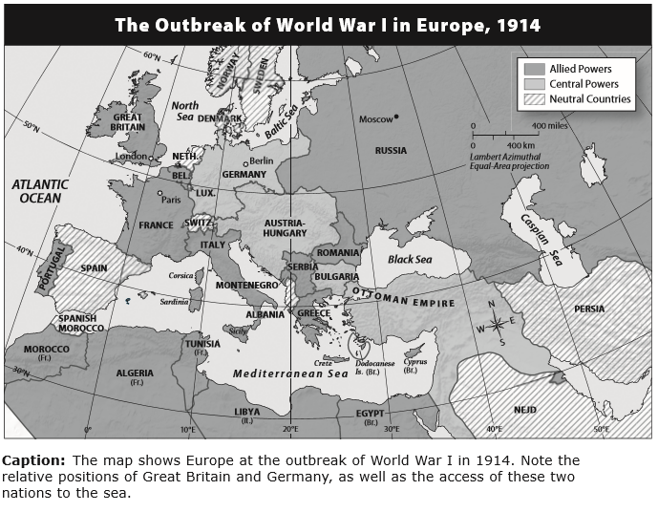
-Worksheet: German Submarine Warfare-
During the early years of World War I (1914–1918), the balance of power—a strategy in which a country (or group of countries) matches its actual or perceived strength against the other side’s power in order to defend itself—between Germany and Great Britain shifted several times. Physical geography played a role in the naval conflict between the two nations as well. Each country was both helped and hindered by its access to the sea. Furthermore, Germany used the new technology of submarines to adapt to its physical environment. This relationship between the environment and society is one of the six essential elements of geography.
As an island nation with a large surface fleet, Britain had long enjoyed access to, and mastery of, the high seas. It was thus a formidable opponent for Germany. On the other hand, with its long coastline and extensive exposure to the sea, Britain was vulnerable to naval blockades.

Germany’s situation was quite different. German access to the sea was narrow, extending only to a few parts of the country’s northern region, and hence to the North and Baltic Seas, the English Channel, and the Atlantic Ocean.
During World War I, both Britain and Germany attempted to deal with these geographical realities through naval blockades. Britain was determined that Germany should receive as little in the way of shipped goods as possible. Germany was equally resolved that supplies to the Allied Powers, especially from the United States, should not reach Britain. With the war at a stalemate, each side was looking to acquire new allies or win some sort of advantage that would break the deadlock.

To accomplish their objective, the Germans turned to a new form of warfare: unrestricted attacks by submarines, or “U-boats.” Since there were no detection methods at the time to locate submarines underwater, this strategy was very effective. Germany announced in 1915 that all waters surrounding Britain made up a “war zone.” It would seek to sink merchant ships, including neutral vessels, attacking without warning. This policy pointedly ignored maritime law, or law of the seas, where all vessels enjoyed freedom of movement in international waters. In May 1915, Germany extended this policy to passenger vessels with the sinking of the British ship Lusitania.

German submarine warfare, developed in a geographic context, had important political effects, since it was one of the main factors leading to the entry of the United States into the war on the Allied side in April 1917.

Questions for Worksheet: German Submarine Warfare
Please use the information above to answer the questions below – answers taken from other sources will not receive credit
1. Reading Maps
a) Which country has a more extensive coastline and access to the sea: Great Britain or Germany?
b) How is this physical feature both an advantage and disadvantage for this nation?
Answer a): Great Britain

Answer b): the coastline made Britain formidable opponent to German. However, the coastline exposed Britain to Naval blockades
2. Making Connections
How does the struggle on the high seas during World War I point to the importance of geography and of a balance of power between potential opponents in wartime?
Answer: the people who were around geographical areas such as coastlines were advantageous because they could hide and attack their enemies.

3. Constructing Arguments
What justification might Germany have used to attack both merchant ships and neutral vessels?
Answer: the merchant ships and neutral vessels were carrying the enemies of Germany.

4. Drawing Conclusions
At first, the United States remained neutral in World War I. Why was unrestricted submarine warfare an important factor in causing the United States to enter the war?
Answer: The Germans used the submarines to destroy the British shipping and the U.S felt that it needed to take control of submarine technologies

-Chapter 27 Lesson 3: The Russian Revolution-
Directions: Read the lesson and complete the outline below. Refer to your textbook to fill in the blanks.

I. Background to Revolution
A. Military and economic missteps during World War I led the Russian people to grow more and more upset with the _________ czarist_________ regime.

B. ________ czar nicholas II __________ reluctantly stepped down on March 15, 1917, ending the 300-year-old Romanov dynasty. The ______________ duma____ had established a temporary government only three days earlier.

C. The authority of the new provisional government was soon challenged by the __ saviets________________ , councils of representatives from the workers and ___________ soldiers_______ .

II. Lenin and the Bolsheviks
A. Under the leadership of Vladimir Ilyich Ulyanov, also known as ________ vi levin ________ , the __ bolsheviks________________ became dedicated to revolution to destroy the exploitive capitalist system that had evolved during the industrial revolution.

B. Bolsheviks promised to end the war, redistribute land to all the peasants, and transfer factories from ___ capitalists______________ to committees of ________ workers_________ .

III. The Bolsheviks Seize Power
A. Bolshevik forces overthrew the provisional government during the night of ___ nov. 6, 1917_______________ .

B. To keep a promise of peace, Lenin signed the __ treaty of brest. litovisk________________, ending Russia’s involvement in the Great War but giving up eastern Poland, Ukraine, Finland, and the Baltic provinces.

IV. Civil War in Russia
A. Anti-Communist forces, with aid and troops from the Allies, fought the Communists on many fronts between the years _________1918________ and __1921_______________ .

B. By 1921, the majority of anti-Communist forces had been defeated; the Communists had retaken Georgia and gained control of governments in ________Ukraine__________ , __Russia Aromenia________________ , and ____Azerbaijan______________ .

V. Triumph of the Communists
A. The Communists triumphed over __anti-communist________________ forces because of a well-disciplined fighting force, a single-minded sense of purpose, ______revolutionary____________ zeal, and strong convictions.

B. A secret police, known as the ____Cheka______________ , began a ____Red Terror____________ , whose aim was to destroy all those opposed to the new regime and keep anticommunist forces from gaining ground within Russia.

Summary & Reflection

Directions: Using ideas from throughout the entire lesson, summarize the main ideas by answering the question below. Answers must be IN YOUR OWN WORDS. DO NOT RESEARCH ANSWERS ONLINE! Points awarded based on accuracy and effort.

Hindsight, they say, is 20-20; meaning that it is easy to see what the problems are and where things went wrong after events have already happened, but when you’re living in a particular time period things are much less clear. Today we can look back at Lenin and the rise of Communist Russia and view it as a huge mistake and a tremendous blight on the history of the world. Yet for the people living through the events, things were not so clear. Answer the following questions to understand why it can be very difficult to see clearly (20-20 vision) while amid historic events.

a) Describe the conditions that existed in Russia that would convince people to support revolutionaries like the Bolsheviks.
b) What are soviets (use the def. on p.549) and how did they bring democracy to a nation run by a dictator/king?
c) Review life during the Industrial Revolution (p. 449 under subheading “new social classes”) Why would the Bolshevik slogan “Worker control of Production” appeal to Russian factory workers and their families? Cite evidence from p.449!
d) Looking ahead: What happened during the Russian Civil War between the Allies and the Bolsheviks that laid the foundation for the future Cold War between the U.S. and Russia (see info p.551/2)?

Answer a): As a result of the weakness of the Provisional Government, economic and social problems and continuation of the war led to growing unrest and support for the Soviets. The Bolsheviks seized power with the help of Led by Lenin.
Answer b): councils composed of representatives from the workers & soldiers. They brought democracy because Lenin and the Bolsheviks saw the soviet as the basic organizing unit of society in a socialist system and supported this form of democracy.

Answer c): it gave Russians the control of fertile lands

Answer d): Russia created enemies with allies of the U.S

-Worksheet: WWI Russian Economy-

Russia's Economy During World War I
When World War I broke out, Russia was ill-equipped to participate effectively. Lacking sufficient weapons and competent military leaders, the Russian army was at a large disadvantage. Czar Nicholas II’s insistence on personally leading the armed forces left his wife, Alexandra, in charge on the home front. She relied on the advice of the mystic Rasputin to run the government. The series of economic and military blunders that followed led to widespread anger with the czarist regime.

By 1917, after three years of war, most of the Russian people no longer had confidence in the czarist regime. Humiliating and costly military defeats had contributed to the unrest. Corruption and inefficiency in the government were rampant. Instead of supporting the czar, the opposition did all it could to undermine his authority, hoping to be in a position to take over once the war ended. One consequence of this infighting was problems with the food supplies.

Even though Russia produced more than enough food to feed its people, various factors such as economic mismanagement and a breakdown in transportation combined to lead to food shortages and price inflation. The winter of 1916–1917 was exceptionally severe, causing food and fuel deliveries to the major cities to decline. The capital, Petrograd (the name for St. Petersburg between 1914 and 1924), was hit especially hard by the shortages.

In February 1917, the government initiated rationing of the bread supply in Petrograd after the price had risen drastically. This was the last straw for the starving population. When riots broke out over the scarcity of food and 10,000 women took to the streets with their demands, they were joined by the very soldiers who had been ordered to fire upon them. It was clear that the people no longer supported the czarist regime, and one week later, Czar Nicholas II was forced to abdicate.

Questions:
1. Explaining
What factors led to inflation in 1916 Russia?
Answer: The autocratic policies of the czars and their resistance to change and the Lack of industrialization and economic growth.

2. Drawing Conclusions
Why did rationing—a common practice during war and times of famine—of bread in February 1917 so enrage the Russian people?
Answer: It left inadequate supplies for the civilian economy

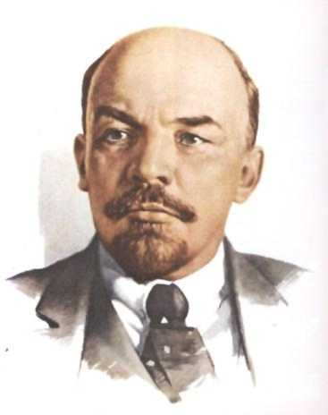
-Worksheet: Vladimir Lenin-
Vladimir Ilyich Lenin (1870–1924)

Vladimir Ilyich Lenin came from a middle-class home and was an excellent student. Despite his brother’s execution as a conspirator against the Russian government, Lenin was allowed to attend university. He became a lawyer, although revolutionary tendencies nearly stopped his practice.

As a lawyer, he mostly defended the poor. He hated the pervasive classism of the legal system. During this time, Lenin associated with Marxists and supported their opposition to capitalism, witnessing how the capitalist system destroyed people in the factories
More About the Image: This image, which was first published around 1920, may be a copy of an earlier photograph or painting.

and mines of the Industrial Revolution. He joined an organization that taught the principles
of Marxism to workers and supported workers’ strikes in order to improve the lives of all
working people.

In 1917, Lenin’s work peaked with his leadership of the Bolshevik Revolution. However, because the working classes continued to support many of Lenin’s policies, the Bolsheviks triumphed.

Questions:
1. Determining Cause and Effect
What possible influence on Lenin’s work as a revolutionary are rooted in his family and in his early work as a lawyer?
Answer: as a lawyer, he was revolutionary and that almost costed his education.

2. Why did Lenin associate with Marxist and oppose capitalism?
Answer: because capitalism embraced the status quo

3. Why did the Bolsheviks triumph over anti-Communists?
Answer: because anti-Communist did not advocate for the rights of common people

-Chapter 27 Lesson 4: World War I Ends-

Directions: Locate each heading below in your textbook. Then use the information under the correct heading and subheading to help you write each answer.

I. The Last Year of the War
A. Who was General Erich Ludendorff?
Answer: was a top German military commander in the latter stages of World War I

B. Who were the German Social Democrats, and what is the significance of November 11, 1918, in relation to the group?
Answer: it consisted of three Majority Social Democrats and three United Social Democrats

C. a) What was the goal of revolutionary forces in Germany after the war?
b) Did they achieve their goals? c) What impact did these revolutionaries have on Germans moving forward?

Answer a): Revolutionary forces in Germany formed the German Communist Party and tried to seize power
in Berlin and Munich.

Answer b): These forces were crushed and left the German middle class with a deep
fear of communism.
Answer c): it made Germans stick together and avoid wars

D. What happened to the Austro-Hungarian Empire after the war?
Answer: Austria-Hungary broke up into the independent republics of Austria, Hungary, and
Czechoslovakia along with the monarchical state called Yugoslavia.

II. The Peace Settlements
A. How did President Woodrow Wilson believe lasting peace could be achieved?
Answer: Wilson believed that lasting peace could be achieved by reaching agreements openly, reducing military forces, and ensuring the right of each people to have their own nation.

B. What were some complications at the Paris Peace Conference, and how were they resolved?
Answer: Many European nations had hoped to make territorial gains after the war. To resolve the issues,
the United States and France compromised on territorial issues, and both nations accepted a
defensive alliance with Great Britain.

C. What were the main provisions of the Treaty of Versailles?
Answer: The Treaty of Versailles declared that Germany (and Austria) were responsible for starting the
war and ordered Germany to pay reparations for all damages that the Allied countries had
sustained.

D. How did the peace settlements change Europe, and what were the long-term effects?
Answer: Many new nations emerged from the former lands of the German, Russian, and Austro-Hungarian empires. Many of the redrawn boundaries however, were not along ethnic lines

Summary & Reflection

Directions: Using ideas from throughout the entire lesson, summarize the main ideas by answering the question below. Answers must be IN YOUR OWN WORDS. DO NOT RESEARCH ANSWERS ONLINE! Points awarded based on accuracy and effort.

a) List out the conditions of the Treaty of Versailles. Explain how these conditions would contribute to a second world war.
b) What became of the Ottoman Empire after the war?
c) How was the mandate system a contradiction of Wilson’s principle of self-determination?
d) Prediction: How might promises broken at the end of WWI contribute to tensions and distrust between Middle Eastern peoples and Western nations? What connection can you see between the conflicts that exist today between the U.S./ Western Europe and the nations of the Middle East? (Hint: consider any of the following: the War in Iraq , tensions with Iran, the war in Afghanistan, and the Wahhabi movement of Saudi Arabia)

Answer a): The Treaty of Versailles held Germany responsible for starting the war and imposed harsh penalties in terms of loss of territory, massive reparations payments and demilitarization. This made Germany furious and started the second world war

Answer b): led to the rise in the Middle East of Western powers such as Britain and France

Answer c): Self determination required every country to govern itself however, the mandate system required the former allies to retain Turkish and German colonies.

Answer d): Middle east people might start thinking that westerna nations are interested in their natural resources and that is why the U.S send his troops to Iraq

-Worksheet: The Second Battle of the Marne-
Why was the Marne River so important to the French and their allies? One reason is the site of the Marne River, and another reason is its situation. Site is a geographic term referring to the physical location of a place, and situation refers to the location of a place based on its relation to other places. The Marne River is located in northeastern France, flowing in an arc generally northwest into the Seine River near Paris. With a total length of 326 miles (525 kilometers) and a series of canals regulating its flow and that of the Seine, the Marne is an important transportation and commerce route. The Marne, along with rails joining Paris and Verdun, was a valuable means of movement and trade. It was important for the French to protect all these assets and locations.
Political geography, which is concerned with the state and its territory, is greatly affected by the international conflicts—such as war—that change borders and create new countries. The political geography of France was in danger of being changed by the events of World War I, but the Second Battle of the Marne proved to be a turning point in the war. This one last German offensive on the Western Front quickly resulted in Germany’s loss.
The German supreme commander, General Erich Ludendorff, had a plan to capture the town of Reims and split France’s armies as preparation for his final offensive against the French troops. He was surprised to discover that French general Ferdinand Foch had anticipated this plan and was ready with strong resistance and counterattacks. The Germans crossed the Marne River in several places, but their advance was quickly stopped. Assisted by British, American, and Italian troops, the French attacked the bulge of German soldiers that had crossed to the south side of the Marne and protruded into the Allied lines. The Germans were soon forced to call off their offensive and retreat. This battle shifted the balance of power in the West.

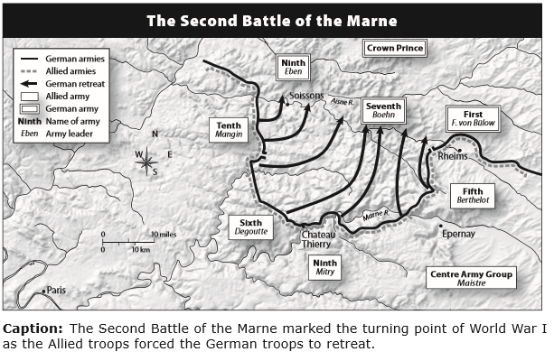

Questions for Worksheet: The Second Battle of the Marne
Please use the information above to answer the questions below – answers taken from other sources will not receive credit
Understanding Concepts
1. Interpreting
According to the map, about how close did the Germans get to Paris before they were forced to retreat?
Answer: very close

2. Explaining
Explain why the Second Battle of the Marne was a turning point in the war.
Answer: Because two divisions of the American Expeditionary Force joined with France to help defeat and stop the Germans from pushing back the French toward Paris.

3. Speculating
What was the geographic significance of the Marne River? Based on your answer, what do you think would probably have happened if the Germans had won the important Second Battle of the Marne?
Answer: the exhausted Germans began a fighting retreat to the Aisne River on September 9.

4. Making Connections
Think about the site and situation in another important World War I battle. What might make this place an attractive or unattractive target for an enemy attack?
Answer: the western front is another site of interest because it’s the main area that German army operated from during WW1

-STOP!-
Do not move on to Unit 8 Section 3 until you have completed the Check-in 8.2.

-STOP!-
Key Assignment is due prior to taking the Unit Test and before moving to the next Unit.

